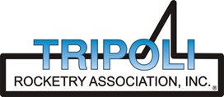
Tripoli Motor Testing Division
223 NC Highway 54 West
Chapel Hill, NC 27514
(919) 357 5681 (c)
December 6, 2022

Gary Rosenfield
RCS Rocket Motor Components, Inc.
2113 West 850 North Street
Cedar City, UT 84721

Dear Mr. Rosenfield,

The Aerotech J1265ST-14A single-use motor was tested on December 4, 2022 and complies with NFPA 1125. The motor is certified for hobby rocketry use by the members of the Tripoli Rocketry Association and all approving organizations with reciprocal certifying agreements.

Motor Manufacturer RCS Rocket Motor Components, Inc.
Manufacturer’s Designation J1265ST-14A [single use, DMS]
Propellant Super Thunder
TMT Nomenclature 1072 J1261

Diameter 2.125” 53.98 mm
Overall Length 15.641” 397.27 mm
Outside the MMT 1.375” 34.93 mm

Loaded Mass 2.414 lb 1095.1 g
Propellant Mass 1.1177 lb* 507 g*
Burnout Mass 1.212 lb 549.71 g
* = data provided by manufacturer

Burn time 0.85 ± 0.007 sec

Total Impulse 251.07 ± 17.04 lbf.s 1072.3 ± 1.563 N.s
Max Impulse 392.36 ± 57.25 lbf 1745.3 ± 254.7 N
Average Impulse 283.51 ± 1.542 lbf 1261.1 ± 6.9 N
Number of Motors Tested 3

Nominal Measured
Delay Time Data 6 s 7.345 s
10 s 10.35 s
14 s 12.925 s

Casing Temp. [NFPA 1125 7.4.1] Passed

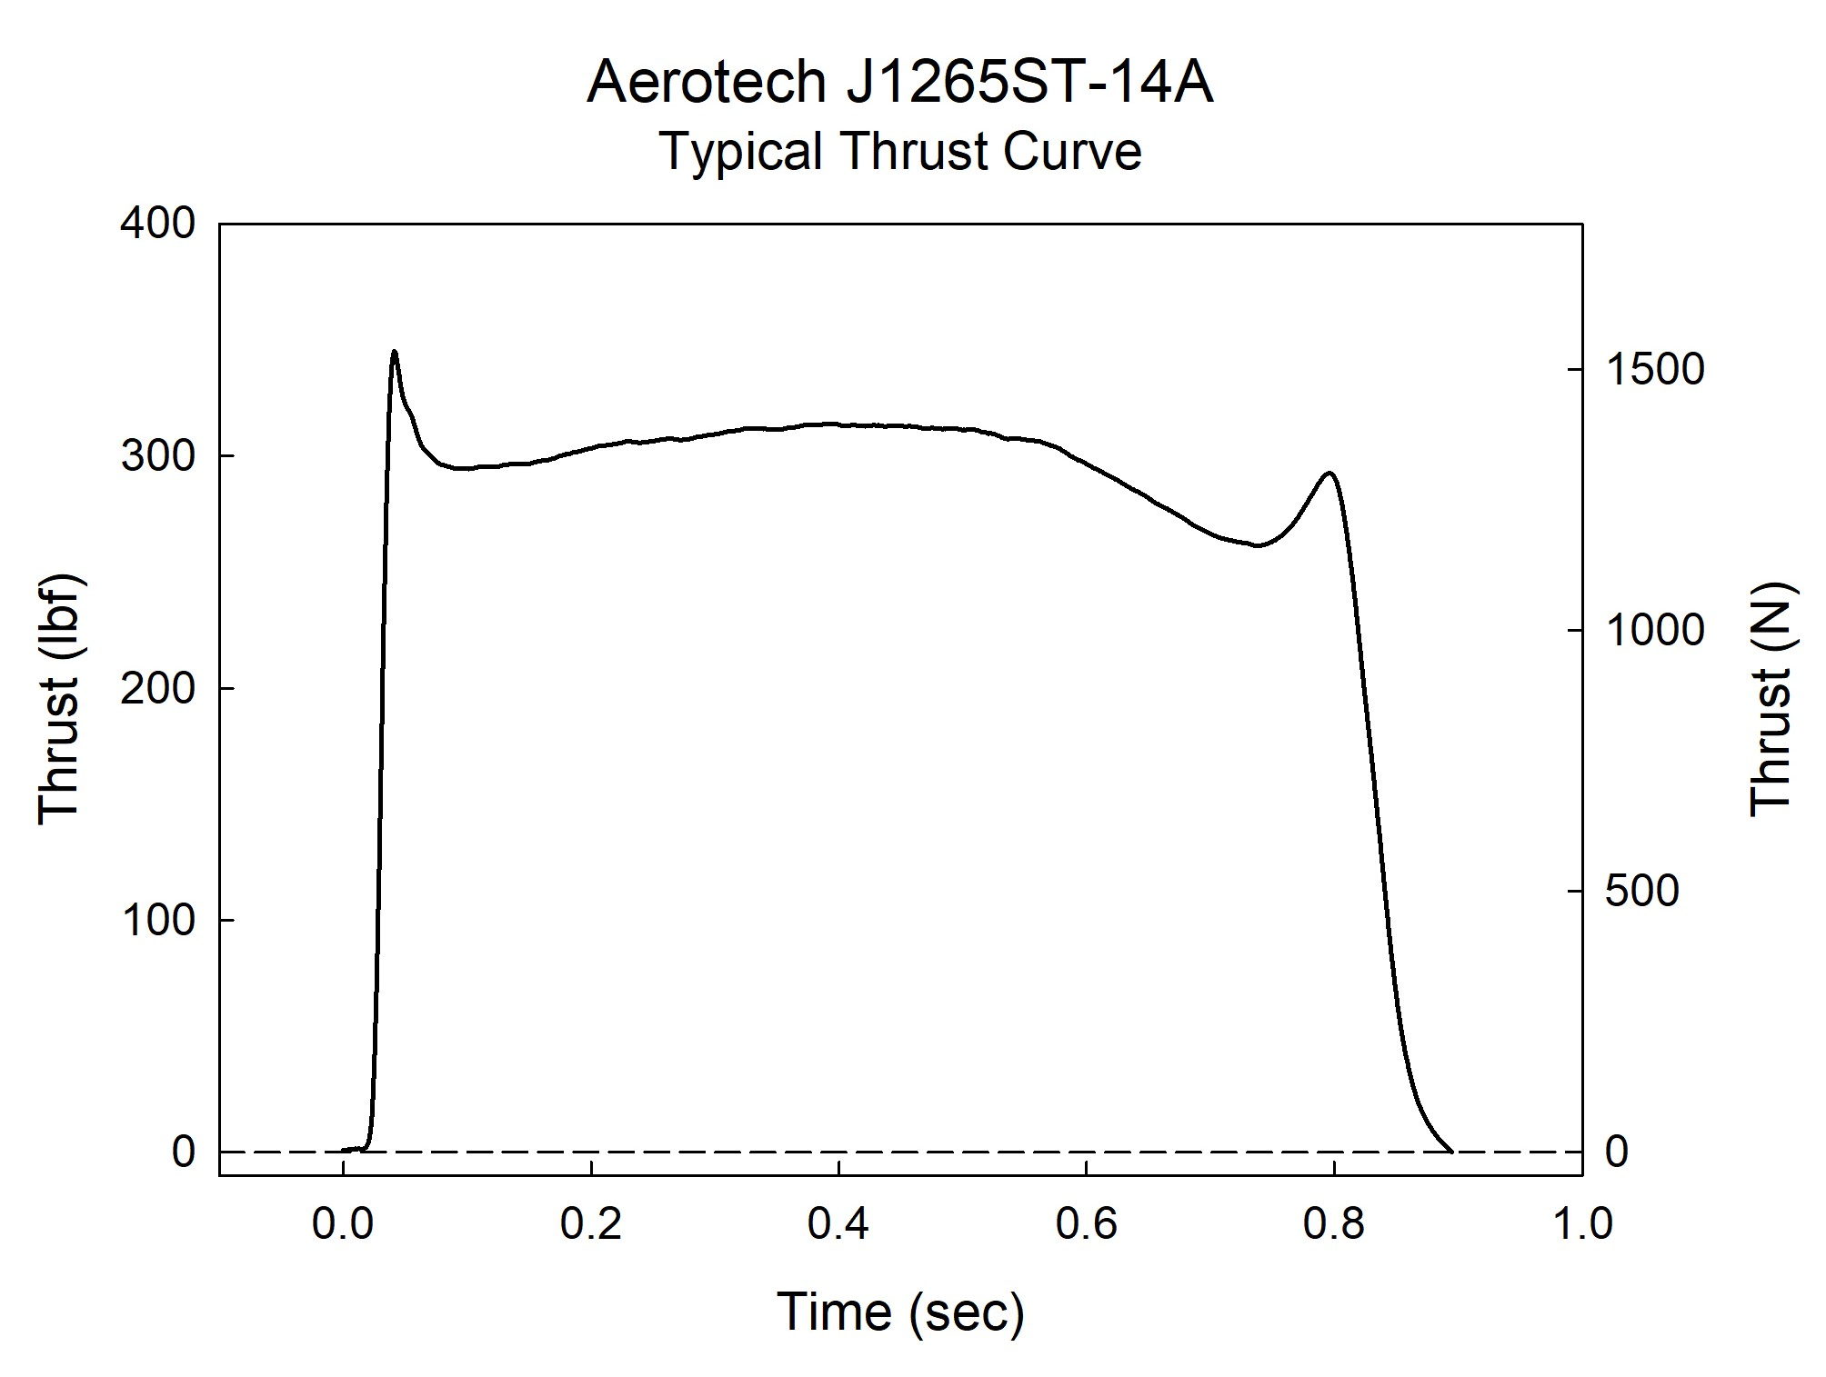

Sincerely,

Alan C. Whitmore
Chair, Tripoli Motor Testing

